MED D - Cancellation of Enrollment

General Information – Cancellation of Enrollment vs. Voluntary Disenrollment
Identify the Benefit Effective Date
Submit a Cancellation of Enrollment Request
Locating a Beneficiary in Fazal
Related Documents

Description: This document provides the CCR and Blue MedicareRx (NEJE) CCR with the proper guidance in addressing questions, concerns and issues surrounding a beneficiary’s request to cancel their enrollment.

General Information – Cancellation of Enrollment vs. Voluntary Disenrollment

- For Medicare Part D plans, the term “Cancellation” strictly refers to a request to revoke a future enrollment request prior to the Benefit Effective Date.

- “Voluntary Disenrollment” is the term associated with ending an enrollment on or after the Benefit Effective Date.

When a beneficiary (or their legal representative) requests to end their Med D Plan, they may use the terms “Cancel” or “Disenroll.” The action taken by the CCR will be based on the Benefit Effective Date.

Top of the Document

Identify the Benefit Effective Date

Perform the following:
Step | Action
1 | Under the Participant Inquiry tab in PeopleSafe, search for the beneficiary.  Refer to Search: Find and View a Member’s Profile in PeopleSafe or RxClaim.
1 | If the beneficiary is… | Then…
1 | Found | The Main Screen will display.  Proceed to Step 2.
1 | NOT Found | Proceed to the Locating a Beneficiary in Fazal section.
2 | On the Medicare D Inquiry Tab in PeopleSafe, review the Benefit Effective date.  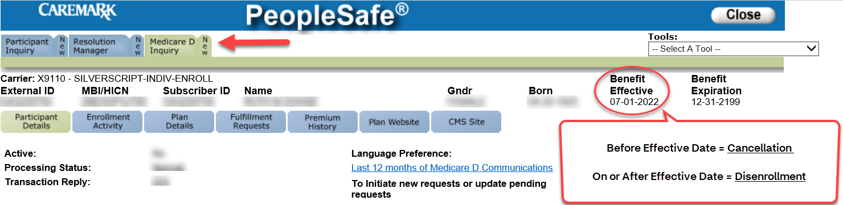
3 | Refer to the chart below to determine the next step:
3 | If the beneficiary is calling… | Then...
3 | BEFORE the Benefit Effective date of enrollment (account is not active) | Proceed to Submitting a Cancellation of Enrollment Request.
3 | ON OR AFTER the Benefit Effective date - (account is active)  OR  Beneficiary says they received a letter advising them to call to cancel. | - Access the Last 12 Months of Medicare D Communications and search for a DOEVL (Outbound Enrollment Verification) Letter  - Review the deadline for cancelling enrollment at the bottom of the letter.  Note: If DOEVL letter is not found, Warm Transfer to the Specialized Member Services Team (SMST).  - SilverScript transfer to 1-833-458-0858  - HealthPlan/EGWP transfer to 1-844-234-8264
3 |  | If the date on the letter is… | Then…
3 |  | Future date | Proceed to Submitting a Cancellation of Enrollment Request.
3 |  | Past date | The request must be treated as a Voluntary Disenrollment.  Warm Transfer to the Specialized Member Services Team (SMST).  - SilverScript transfer to 1-833-458-0858  - HealthPlan/EGWP transfer to 1-844-234-8264  Advise the SMST that the beneficiary is past the Cancellation date and requesting disenrollment.

Top of the Document

Submit a Cancellation of Enrollment Request

Perform the following:
Step | Action
1 | Review the Enrollment Source field on the Medicare D Inquiry Tab – Participant Details in PeopleSafe.  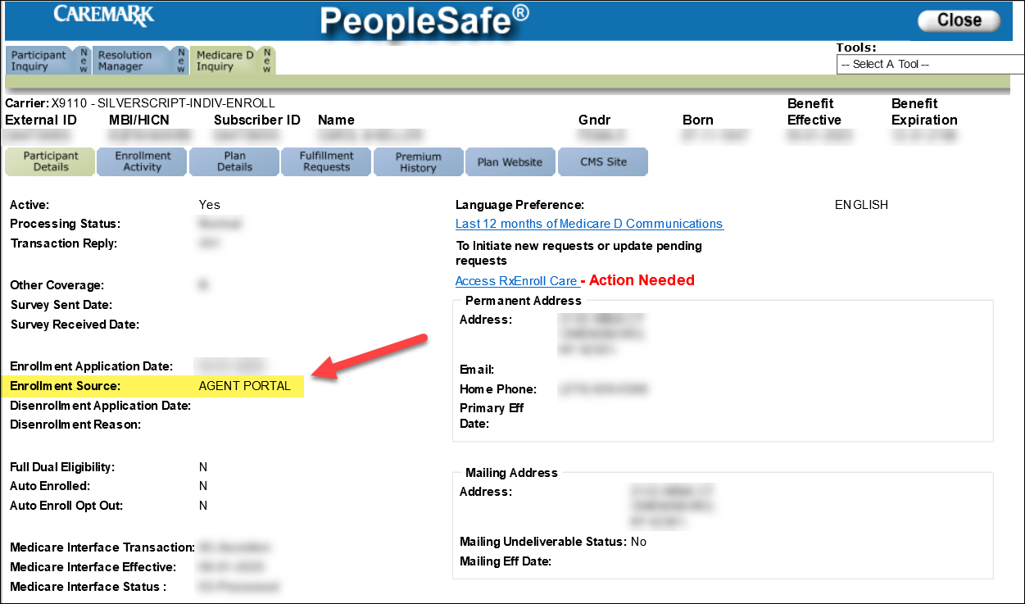  Proceed to the next step.
2 | Determine the appropriate action:
2 | If the Enrollment Source is… | Then…
2 | CMS Auto/Facilitated, TRC 117 or TRC 118 or 212 | Medicare (CMS) enrolled the beneficiary. Advise the beneficiary that they can choose to opt out of future enrollments prior to submitting cancellation.  - Our records show that you were automatically enrolled in <Plan Name>. Medicare will continue to enroll you into a plan in a monthly auto-enrollment process unless you choose to opt-out of this process. However, if you choose to opt-out of this process, you will be responsible for your plan choices in the future.  - Please be aware that if you go without creditable prescription drug coverage for more than 63 days, you may incur a Late Enrollment Penalty. Additionally, if you previously had drug coverage through Medicaid that program will no longer pay for your prescription medications.  Note: If the beneficiary indicates that they already have creditable coverage through an employer/group plan or through another source such as VA, they may not be subject to Late Enrollment Penalty.  How would you like to proceed?
2 | CMS Auto/Facilitated, TRC 117 or TRC 118 or 212 | If…. | Then…
2 | CMS Auto/Facilitated, TRC 117 or TRC 118 or 212 | No, beneficiary does not wish to Opt Out of Future Enrollments | Submit the following RM Task in PeopleSafe:  Task Category: Med D Enrollment - Enrollment  Task Type: Cancellation of Enrollment  Queue: Med D Enrollment Task  Notes:  - Today’s date  - Caller (Beneficiary, POA/Legal Representative, and Ship Counselor) is requesting to cancel his/her enrollment request effective xx/xx/xxxx.  - The beneficiary does not wish to opt-out of future automatic/facilitated enrollments.  - If needed provided Legal Rep or POA (Full name, address, and phone number, and relationship to the beneficiary).  - We will submit a request to have your enrollment cancelled. Please understand that the turnaround time for this request can take up to 10 days. A letter regarding your request to cancel will be sent to your address on file in response to this request.  - If we receive notification that your request has been accepted, you will receive a confirmation letter within 10 calendar days.  Proceed to next step.
2 | CMS Auto/Facilitated, TRC 117 or TRC 118 or 212 | Yes, beneficiary wants to Opt Out of Future Enrollments | Submit the following RM Task in PeopleSafe:  Task Category: Med D Enrollment - Enrollment  Task Type: Cancellation of Enrollment  Queue: Med D Enrollment Task  Notes:  - Today’s date  - Caller (Beneficiary, POA/Legal Representative, and Ship Counselor) is requesting to cancel his/her enrollment request effective xx/xx/xxxx.  - Beneficiary understands the consequences of choosing to opt out of the auto enrollment process  - If needed provided Legal Rep or POA (Full name, address, and phone number, and relationship to the beneficiary).  - By declining automatic enrollment, you will no longer be included in future automatic enrollments by Medicare.  - We will submit a request to have your enrollment cancelled. Please understand that the turnaround time for this request can take up to 10 days. A letter regarding your request to cancel will be sent to your address on file in response to this request.  - If we receive notification that your request has been accepted, you will receive a confirmation letter within 10 calendar days.  Proceed to the next step.
2 | Rollover - Beneficiary is a rollover from another plan (acquired or changed) | A voluntary disenrollment is required to be removed from the plan.  Warm Transfer to the Specialized Member Services Team (SMST).  - SilverScript transfer to 1-833-458-0858  - HealthPlan/EGWP transfer to 1-844-234-8264
2 | All other sources | Submit the following RM Task in PeopleSafe:  Task Category: Med D Enrollment - Enrollment  Task Type: Cancellation of Enrollment  Queue: Med D Enrollment Task  Notes:  - Today’s date  - Caller (Beneficiary, POA/Legal Representative, and Ship Counselor) is requesting to cancel his/her enrollment request effective xx/xx/xxxx.  - If needed provided Legal Rep or POA (Full name, address, and phone number, and relationship to the beneficiary).  - We will submit a request to have your enrollment cancelled. Please understand that the turnaround time for this request can take up to 10 days. A letter regarding your request to cancel will be sent to your address on file in response to this request.  - If we receive notification that your request has been accepted, you will receive a confirmation letter within 10 calendar days.  Proceed to the next step.
3 | - Thank you for your time today.  - As a quality measure, have I fully answered and resolved <your/the beneficiary’s> question(s) to <your/the beneficiary’s> satisfaction?
3 | If… | Then…
3 | Yes | Close the call:  - Address any other issues, if needed.  - Document and close the call according to existing policies and procedures, including all options discussed. Refer to the MED D - Call Documentation work instruction.
3 | No | - Ask additional probing questions to attempt to resolve remaining questions or concerns.  - If unable to resolve the questions/concerns, transfer the call to a Supervisor.

Top of the Document

Locating a Beneficiary in Fazal

Perform the following:
Step | Action
1 | In FAZAL, search for enrollment information specific to the beneficiary using the name and date of birth.  Refer to:  - MED D - SilverScript - Resolution of Eligibility  - MED D - Blue MedicareRx (NEJE) - Resolution of Eligibility  Note: The search results are displayed by Batch Date with the most recent application listed first. The CCR should always view the most recent application submitted.  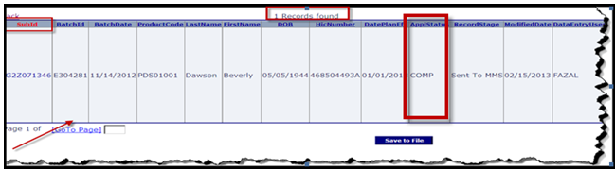  Proceed to the next step.
2 | Click on the SubId hyperlink for the enrollment record.  Result: Section 1 of the Enrollment Form View screen will display.
3 | Review the Data Origin shown at the top of section 1 of the enrollment record. The Data Origin is the enrollment source.  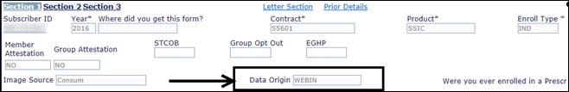
3 | If the enrollment source is… |  |  | Then…
3 | CMSA  CMSF  CMSR | Beneficiary is an auto, facilitated or reassigned enrollee |  | - Our records show that you were automatically enrolled in <Plan Name>. Medicare will continue to automatically enroll you into a plan in a monthly auto-enrollment process unless you choose to opt-out of this process. However, if you choose to opt-out of this process, you will be responsible for your plan choices in the future.  - Please be aware that if you go without creditable prescription drug coverage for more than 63 days, you may incur a Late Enrollment Penalty. Additionally, if you previously had drug coverage through Medicaid that program will no longer pay for your prescription medications.  Note: If the beneficiary indicates that they already have creditable coverage through an employer/group plan or through another source such as VA, they may not be subject to Late Enrollment Penalties.  - Do you wish to opt-out of future enrollments?  - If Yes,  - By declining automatic enrollment, you will no longer be included in future automatic enrollments.  - If No,  - Your enrollment in the plan will be cancelled, however you will still be included in future automatic enrollments.  Proceed to the next step and indicate in the notes: Beneficiary does or does not wish to opt-out of auto/facilitated enrollment process.
3 | AGNTP  C:D  FAX  ICALL  MAIL  MLPAP  OECT  PAPER  WEBIN  WRAPX  RAPXW | Beneficiary is a beneficiary elect |  | Proceed to the next step.
3 | Rollover | Beneficiary is a rollover from another plan (acquired or changed) |  | A Voluntary Disenrollment is required to be removed from the plan.  Warm Transfer to the Specialized Member Services Team (SMST).  - SilverScript transfer to 1-833-458-0858  - HealthPlan/EGWP transfer to 1-844-234-8264  Note: Do not send a Cancellation of Enrollment Routed Task.  Proceed to the next step.
4 | Review the ApplStatus shown on the search results:
4 | If the ApplStatus is… |  |  | Then…
4 | INCPCMS  INCPDENL  INCPDUP  INCPFSCRUB  INCPHOLD  INCPOPS |  |  | Proceed to the next step.
4 | DENL |  |  | If the beneficiary has no other applications, and has no eligibility in PeopleSafe, no further action is needed.  Proceed to Step 8.
4 | COMP  DUPCLOSED |  |  | Review effective dates for these enrollments. If the beneficiary has a future effective date, search in PeopleSafe again using the GID located in the enrollment or notes in the enrollment.
4 |  |  |  | If… | Then…
4 |  |  |  | Beneficiary is located in PeopleSafe with future eligibility | Refer to Step 2 in Identify the Benefit Effective Date.
4 |  |  |  | Beneficiary is not located in PeopleSafe and/or does not have future eligibility | Submit an RM Task using the notes from Submit a Cancellation of Enrollment Request Step 2.
5 | Click on the Section 3 hyperlink of the Enrollment Form View screen.  Result: Section 3 of the Enrollment Form View screen will display.  Proceed to the next step.
6 | Select Member Requests Cancellation in the CSR Category dropdown box.  Enter the following:  - Date  - “Caller (Beneficiary, POA/Legal Representative, and Ship Counselor) is requesting to cancel his/her enrollment request effective xx/xx/xxxx.”  - If needed, provided Legal Rep or POA, or Ship Counselors (Full name, address, and phone number, and relationship to the beneficiary).  Note: Only beneficiaries, designated individuals with POA or AOR/Legal Representative documentation, or a SHIP Counselor can request to cancel a beneficiary’s enrollment in a MED D prescription drug benefit plan.  Proceed to the next step.
7 | Click the X on the top right of the screen to save and close the application.  Proceed to the next step.
8 | - Thank you for your time today.  - As a quality measure, have I fully answered and resolved <your/the beneficiary’s> question(s) to <your/the beneficiary’s> satisfaction?
8 | If… |  | Then…
8 | Yes |  | Close the call:  - Address any other issues.  - Document and close the call according to existing policies and procedures, including all options discussed. Refer to the MED D - Call Documentation work instruction.
8 | No |  | - Ask additional probing questions to attempt to resolve remaining questions or concerns.  - If unable to resolve the questions/concerns, transfer the call to a Supervisor.

Top of the Document

Related Documents
- Grievance Standard Verbiage (for use in Discussion with Beneficiary) section in MED D - Grievances Index
- MED D Enrollment - FAZAL
- MED D - SHIP Counselor Calls for CVS Caremark Part D Plans
- MED D - Appointed Representative Form (AOR) or Power of Attorney (POA)
- MED D - SilverScript and Blue MedicareRx (NEJE) - Enrollment Related RM Tasks
- MED D - Election Periods for Enrollment and Disenrollment (AEP, IEP, SEP)

Parent SOP:
- MEDS-0006: Medicare Part D - Cancellation of Enrollment and Disenrollment Policy and Procedure, CVS Caremark Part D Services, L.L.C.
- CALL-0048: Medicare Part D - Customer Care Call Center Requirements, CVS Caremark Part D Services, L.L.C.
Abbreviations/Definitions:
- Abbreviations / Definitions
Top of the Document

Not to Be Reproduced or Disclosed to Others without Prior Written Approval
ELECTRONIC DATA = OFFICIAL VERSION / PAPER COPY = INFORMATIONAL ONLY

